User Guide

Background:
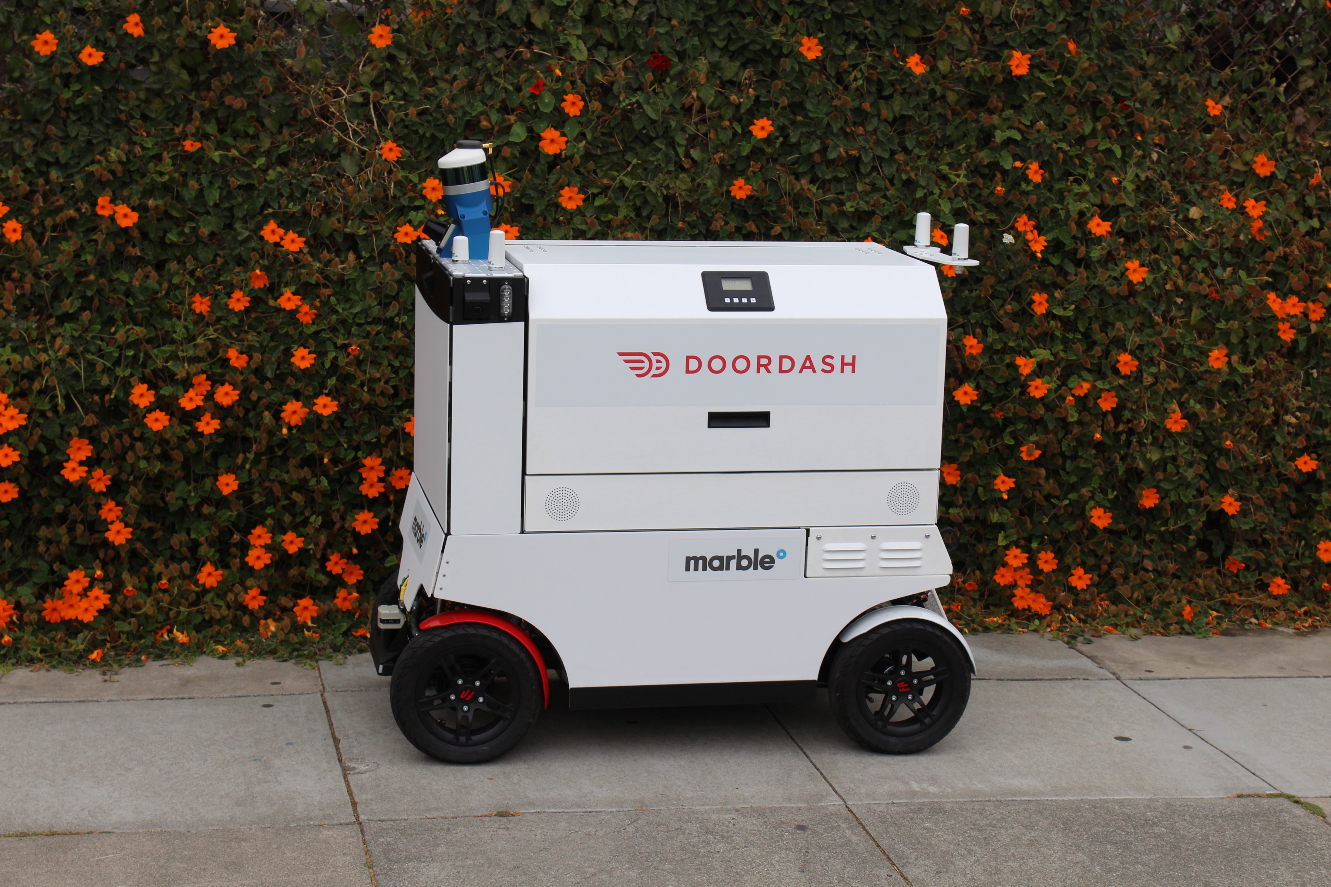

Details:

- GPS Tracker this features permits to the customer to see where the robots it is.
- Anti Theft Mode with this features nobody can stoile the food inside the robots
- Pernolize delivery with this featues the customer can pesonalize the order

Yout Dasher is on thw way !
- this features permits to the customer to see where the robots it is.
- The user can use this feature using our app
- We may have that sometimes our robot is stuck and we may need to unstuck it
- Here is our feature :
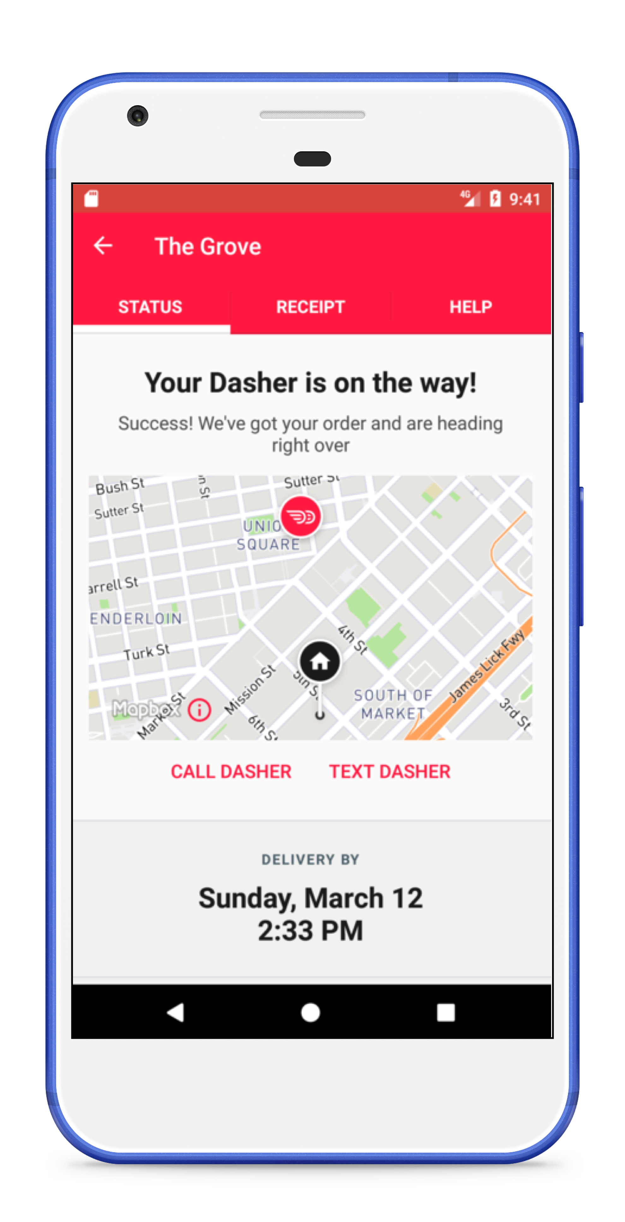

Yout Dasher won't be stoled
- this features permits that nobody can stole your food
- The user will receive an SMS to unlock the robot
- Somebody may stole the robot itself but anyway the police will already know

Here is our feature : those are camera that take at 360 view and register everything
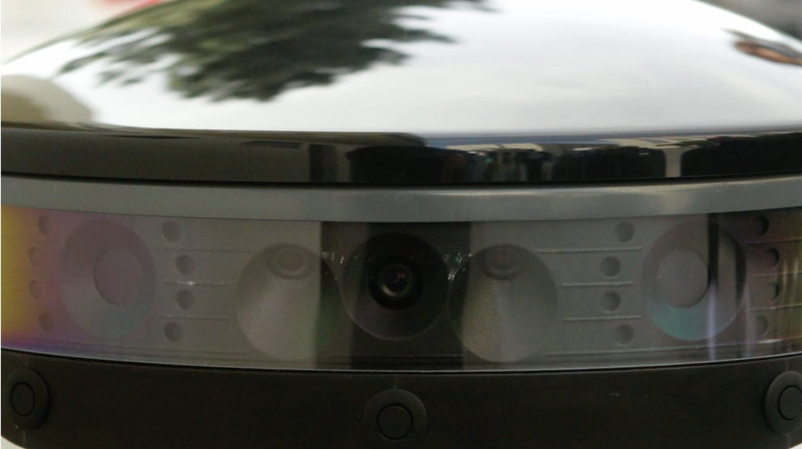
https://www.youtube.com/watch?time_continue=53&v=UPZwnc_Lk2M&feature=emb_logo

